

**ASSIGNMENT**

**on**

***Internet Programming Laboratory***

***COURSE CODE: CSE 326***

Submitted to

Kunj Marken

Submitted by

Section- K19JF

Group-14

Anand Gupta - 11904979 - B40

Prakhar Srivastava -11904878 - B41

Sandesh Acharya - 11904881 - B42

**School of Computer Science & Engineering**

**Lovely Professional University, Phagwara, Punjab**

**Synopsis of Online Movie Ticket Booking System**

**Introduction of the Project Online Movie Ticket Booking System:**

The "Online Movie Ticket Booking System" has been developed to override the

problems prevailing in the practicing manual system. This software is supported to

eliminate and in some cases reduce the hardships faced by this existing system.

Moreover this system is designed for the particular need of the company to carry out

operations in a smooth and effective manner.

The application is reduced as much as possible to avoid errors while entering the data.

It also provides error message while entering invalid data. No formal knowledge is

needed for the user to use this system. Thus by this all it proves it is user-friendly.

Online Movie Ticket Booking System , as described above, can lead to error free,

secure, reliable and fast management system. It can assist the user to concentrate on

their other activities rather to concentrate on the record keeping. Thus it will help

organization in better utilization of resources.

Every organization, whether big or small, has challenges to overcome and managing

the information of Tickets, Movie, Show Timing, Audi, Customer. Every Online Movie

Ticket Booking System has different Movie needs, therefore we design exclusive

employee management systems that are adapted to your managerial requirements.

This is designed to assist in strategic planning, and will help you ensure that your

organization is equipped with the right level of information and details for your future

goals. Also, for those busy executive who are always on the go, our systems come with

remote access features, which will allow you to manage your workforce anytime, at all

times. These systems will ultimately allow you to better manage resources.

**Abstract of the Project Online Movie Ticket Booking System:**

The purpose of Online Movie Ticket Booking System is to automate the existing manual system by the help of computerized equipments and full-fledged computer software, fulfilling their requirements, so that their valuable data/information can be stored for a longer period with easy accessing and manipulation of the same. The required software and hardware are easily available and easy to work with.

**Objective of Project on Online Movie Ticket Booking System:**

The main objective of the Project on Online Movie Ticket Booking System is to

manage the details of Movie, Tickets, Booking, Show Timing, Customer. It manages all

the information about Movie, Audi, Customer, Movie. The project is totally built at

administrative end and thus only the administrator is guaranteed the access. The

purpose of the project is to build an application program to reduce the manual work for

managing the Movie, Tickets, Audi, Booking. It tracks all the details about the Booking,

Show Timing, Customer.

**Functionalities provided by Online Movie Ticket Booking System are as follows:**

• Provides the searching facilities based on various factors. Such as Movie,

Booking, Show Timing, Customer

• Online Movie Ticket Booking System also manage the Audi details online for

Show Timing details, Customer details, Movie.

• It tracks all the information of Tickets, Audi, Show Timing etc

• Manage the information of Tickets

• Shows the information and description of the Movie, Booking

• To increase efficiency of managing the Movie, Tickets

• It deals with monitoring the information and transactions of Show Timing.

• Manage the information of Movie

• Editing, adding and updating of Records is improved which results in proper

resource management of Movie data.

• Manage the information of Show Timing

• Integration of all records of Customer.

**Scope of the project Online Movie Ticket Booking System:**

It may help collecting perfect management in details. In a very short time, the

collection will be obvious, simple and sensible. It will help a person to know the

management of passed year perfectly and vividly. It also helps in current all works

relative to Online Movie Ticket Booking System. It will be also reduced the cost of

collecting the management & collection procedure will go on smoothly.

Our project aims at Business process automation, i.e. we have tried to

computerize various processes of Online Movie Ticket Booking System.

• In computer system the person has to fill the various forms & number of copies of

the forms can be easily generated at a time.

• In computer system, it is not necessary to create the manifest but we can directly

print it, which saves our time.

• To assist the staff in capturing the effort spent on their respective working areas.

• To utilize resources in an efficient manner by increasing their productivity through

automation.

• The system generates types of information that can be used for various

purposes.

• It satisfy the user requirement

• Be easy to understand by the user and operator

• Be easy to operate

• Have a good user interface

• Be expandable

• Delivered on schedule within the budget.

**Modules of Online Movie Ticket Booking System:**

•Home Module: It is home page of this website, from here we can book movie tickets.

•About Module: It is for brief information of the website.

• Contact Us Module: It is for any queries or complain

• Timing Module: Used for managing the Show Timing information.

• Cinemas Module: Used for managing the information and details of the Tickets

• Movie Module: Used know the Movie details.

**Conclusion:**

• We have learn how to design website using html and CSS.

• In this project we have also learnt how to make different tab in one website.

• In this project we designed contact us form where user can contact us.

•From this website user can book Movie ticket from their home.

**Bibliography:**

• https://www.tutorialspoint.com/java/

• http://www.javatpoint.com/java-tutorial

• Database Programming with JDBC and Java by O'Reilly

• http://www.wampserver.com/en/

• http://www.bookmyshow.com

.

Home

About

Contact US

Cinemas

Timing

Movie

Contact Us

About

Home

Booking Management System

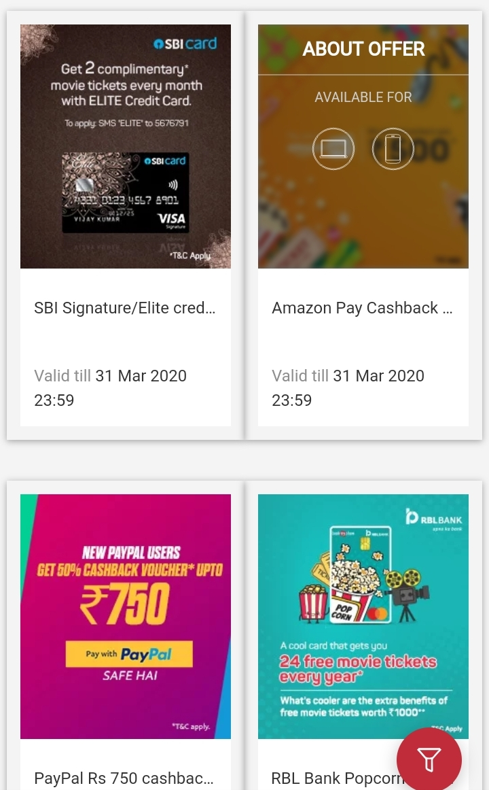 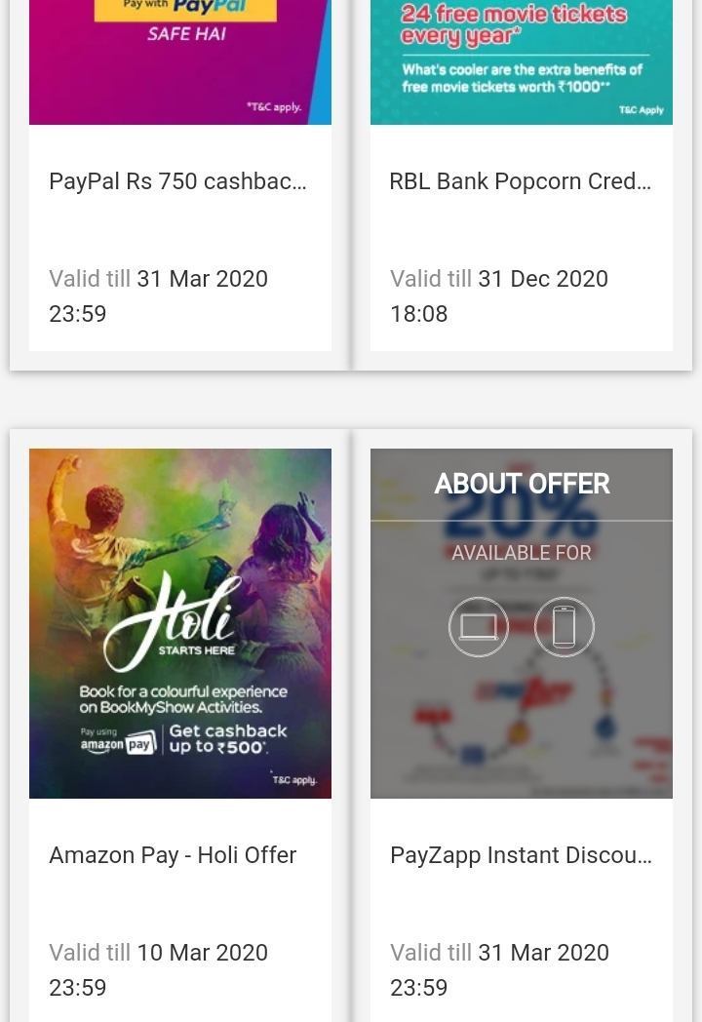 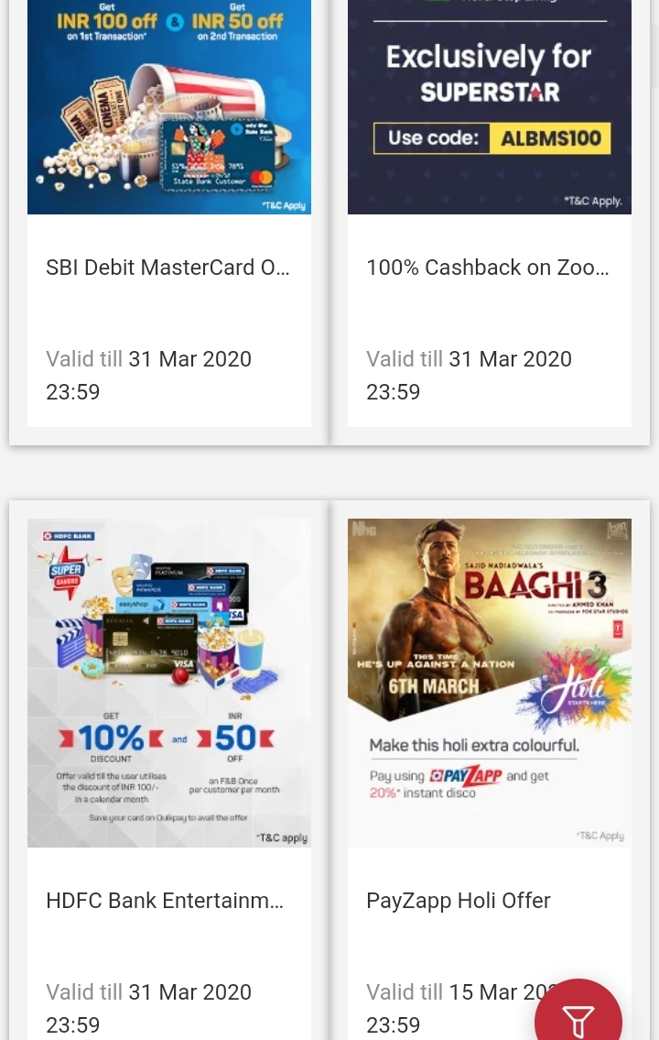

Timing

Movie2



Movie3



Movie1



Cinemas